<https://developer.oculus.com/documentation/native/pc/dg-render-advanced/?locale=en_US>

<https://developer.download.nvidia.com/video/gputechconf/gtc/2019/presentation/s91047-vive-pro-eye-tracking-and-foveated-rendering-with-vrs-presented-by-htc-vive.pdf>

<https://blogs.unity3d.com/2017/11/21/how-to-maximize-ar-and-vr-performance-with-advanced-stereo-rendering/?_ga=2.236081545.969120911.1585681922-1632791246.1581533918>

<https://github.com/c-jensen/UnityFoveatedRendering>

<https://github.com/shimins/Eyetracking/blob/91617fce87f7a19b91f449b1643405703407751f/EyeTracking/Basic%20Eyetracking%20Sample/WPFControl.xaml.cs>

<https://github.com/ViveSoftware/ViveFoveatedRendering/blob/35383c279ced5d3f8901fc123b7509e8e95ae364/UnityPackage/ViveFoveatedRendering/Scripts/ViveFoveatedRendering.cs>

<https://forum.vive.com/topic/7434-getting-started-with-vrs-foveated-rendering-using-htc-vive-pro-eye-unreal-engine/>

# 

# 

# How to display content in left/right eye

<https://forum.unity.com/threads/steamvr-how-to-display-content-in-left-right-eye.396236/>

<https://docs.unity3d.com/Manual/Layers.html?_ga=2.127220229.969120911.1585681922-1632791246.1581533918>

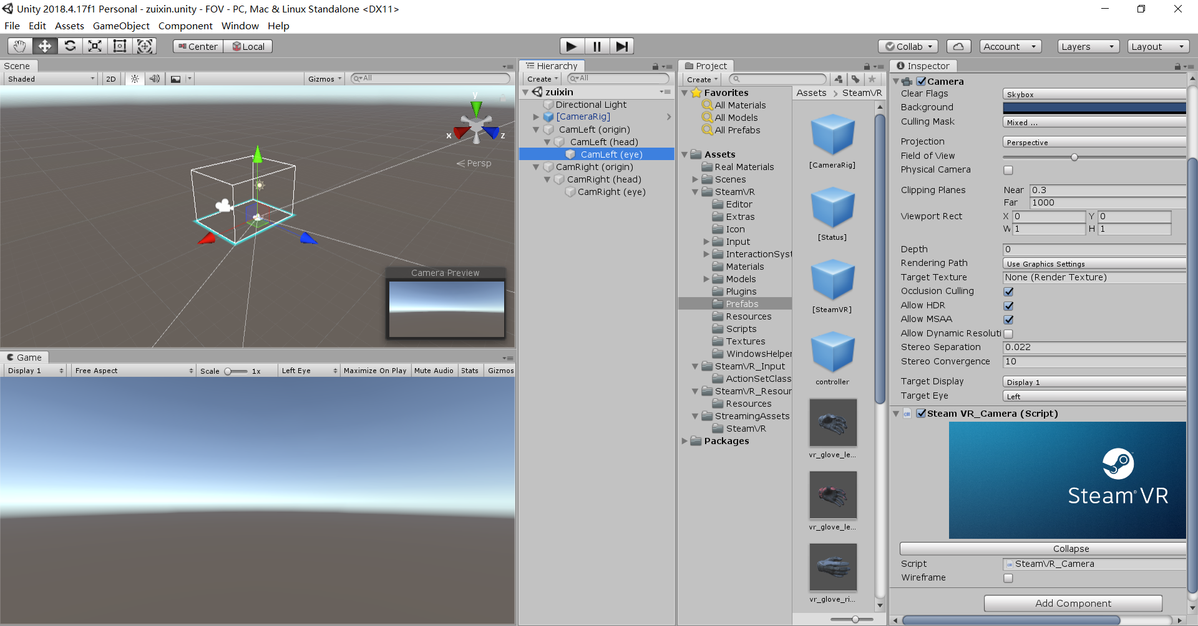

steam vr rendering process：

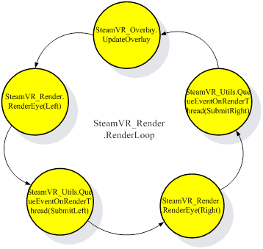

ViveFoveatedRendering: <https://github.com/ViveSoftware/ViveFoveatedRendering/blob/master/UnityPackage/ViveFoveatedRendering/Editor/ViveFoveatedRendering_Editor.cs>

<https://stackoverflow.com/questions/20573166/focal-length-to-field-of-view>